**Module (JAVASCRIPT BASIC & DOM) – 4**

(Basic logic Question)

**Que 1. What is JavaScript. How to use it?**

**Ans 1.** JavaScript is a programming language which add functionality

Into a simple web page and it is used to create dynamic and interactive content on websites. It is one of the core

technologies of the World Wide Web, alongside HTML and CSS.

To use JavaScript, we need to Embedded in html

We can embed or link by three different ways.

1**.Inline Script**: Directly within HTML elements

2.**Internal Script**: Inside a <script> tag within the HTML document.

3.**External Script**: Linking an external JavaScript file.

**Que 2. How many type of Variable in JavaScript?**

**Ans 2.** There are mainly Three types of variables in JavaScript:

**1.let:**

**Scope:** Block-scoped. Variables declared with let are limited to the block (enclosed by {}) in which they are declared.

**Hoisting:** Variables declared with let are hoisted to the top of the block but are not initialized. Accessing them before the declaration results in a ReferenceError.

**Re-declaration:** You cannot re-declare variables using let within the same scope

**2.var:**

**Scope:** Function-scoped. Variables declared with var are limited to the function in which they are declared.

**Hoisting:** Variables declared with var are hoisted to the top of their containing function or global scope. This means you can use the variable before it is declared, but it will be undefined until the declaration is encountered.

**Re-declaration:** You can re-declare variables using var within the same scope without causing an error.

**3.const:**

**Scope:** Block-scoped, like let.

**Hoisting:** Variables declared with const are hoisted to the top of the block but are not initialized. Accessing them before the declaration results in a ReferenceError**.**

**Re-declaration**: You cannot re-declare variables using const within the same scope.

**Assignment:** Variables declared with const must be initialized at the time of declaration and cannot be reassigned afterwards.

**Que 3. Define a Data Types in JavaScript?**

**Ans 3.  01. Primitive data:**

**- Number**: Represents both integer and floating-point numbers.

**- String:** Represents a sequence of characters.

**- Boolean:** Represents a logical entity and can have two values: true and false.

- **null – object:** Represents the intentional absence of any object value.

**- undefined:** Represents a variable that has been declared but not assigned a value.

**- Symbol:** Represents a unique and immutable identifier.

**- Big int:** Represents integers with arbitrary precision.

**02. Non- primitive data:**

**- Array:** Used to store ordered collections of items.

**- Function**: Represents a block of code designed to perform a particular task.

**- Object:** Used to store collections of data and more complex entities.

**Ques 4:** **Write a mul Function Which will Work Properly When invoked With Following Syntax?**

**Ans 4.**

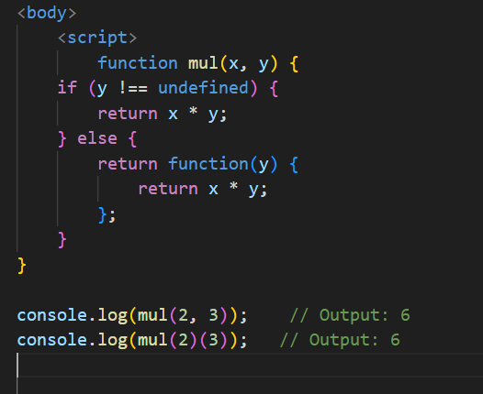

**Que 5. What the deference between undefined and undeclare in JavaScript?**

**Ans 5.** In JavaScript, undefined and undeclared refer to two different states related to variables, and it's important to understand the distinction between them:

**Undefined:**

A variable is undefined when it has been declared but has not been assigned a value. It is one of the primitive data types in JavaScript.

### Undeclared

A variable is undeclared when it has not been declared in any scope. Attempting to access an undeclared variable result in a Reference Error.

**Que 6: Using console.log() print out the following statement: The quote 'There is no exercise better for the heart than reaching down and lifting people up.' by John Holmes teaches us to help one another. Using console.log() print out the following quote by Mother Teresa:**

**Ans:** 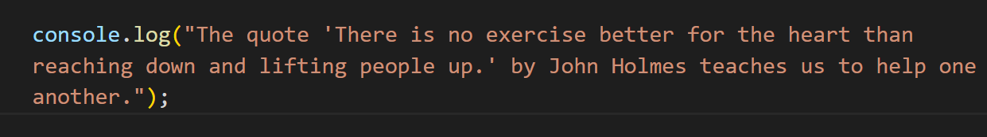

**Que 7. Check if type of '10' is exactly equal to 10. If not make it exactly equal?**

**Ans 7:**

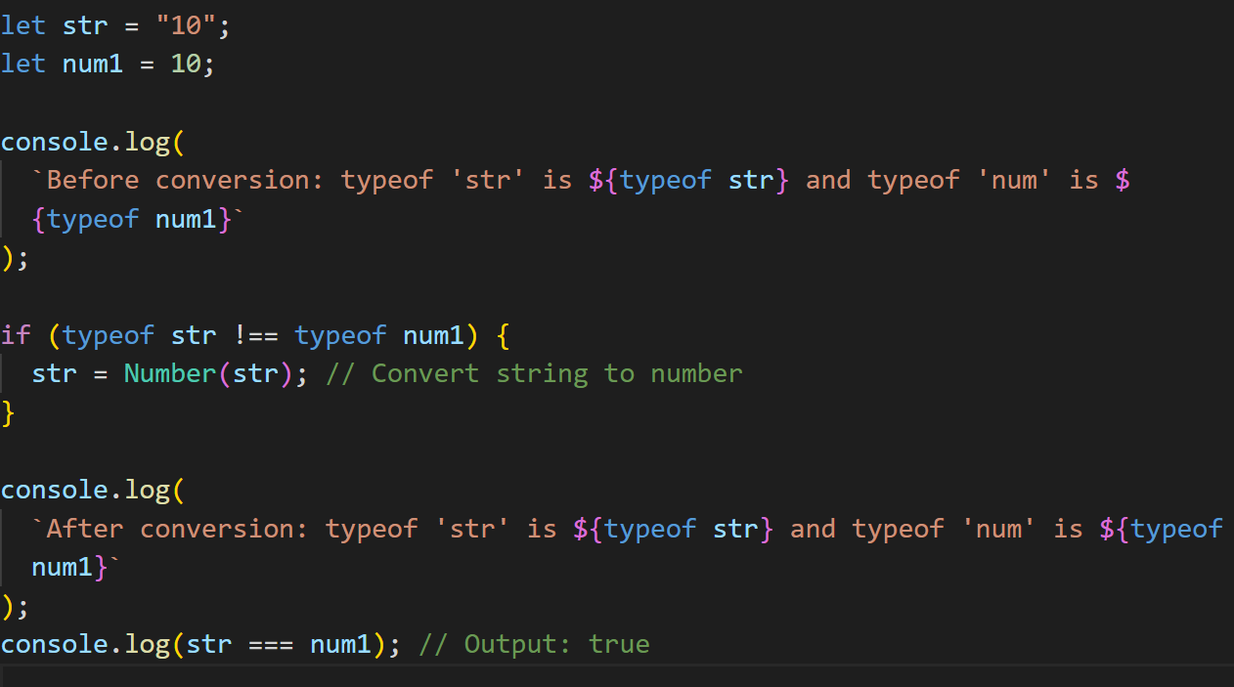

**Ques 8. Write a JavaScript Program to find the area of a triangle?**

**Ans 8.** 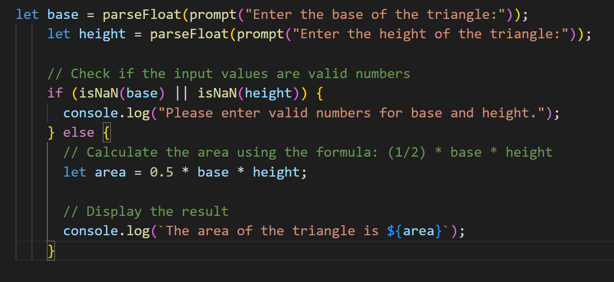

**Ques 9**. **Write a JavaScript program to calculate days left until next Christmas?**

**Ans 9.** 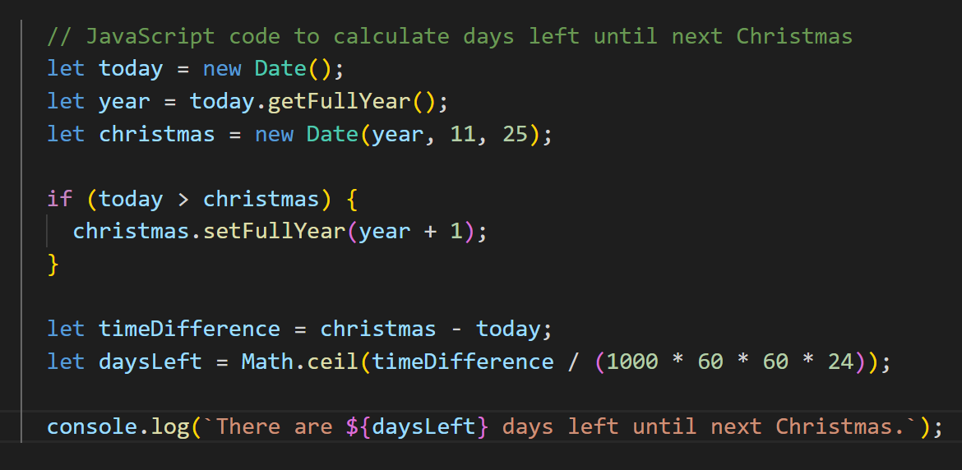

**Que 10. What is Condition Statement?**

**Ans 10.** A conditional statement, also known as a control flow statement, is a feature in programming that allows the code to make decisions and execute different blocks of code based on certain conditions. In JavaScript, conditional statements include if, else if, else, switch, and the ternary operator (? :). These statements evaluate expressions and, depending on whether the expressions are true or false, execute specific code blocks

**Types of conditional statement:**

* **If statement**
* **If else statement**
* **Nested if else if statement**
* **Ternary operator**
* **Switch case**

**IMP: Question 11 to 29 are in code file. Few theory question are mention below with answer.**

**Que 14. Write a JavaScript exercise to get the extension of a filename.?**

**Ans 14.**

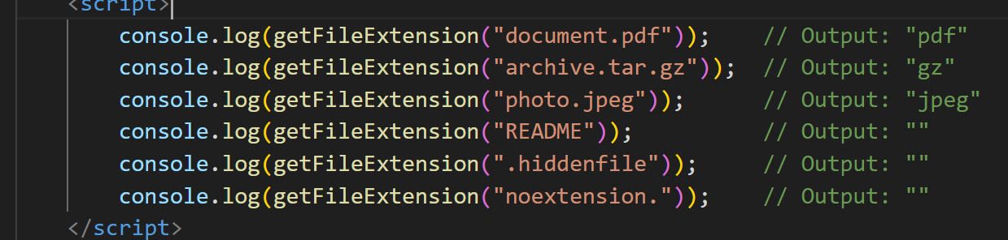

**Que 18. What is a Loop and Switch Case in JavaScript define that?**

**Ans 18.**

Loops are used in JavaScript to repeatedly execute a block of code as long as a specified condition is true. There are several types of loops in JavaScript:

1. **For loop**: The For loop is used when you know in advance how many times you want to execute a statement or a block of statements.
2. **While loop**: The while loop executes its statements as long as a specified condition evaluates to true. The condition is evaluated before executing the statements.
3. **Do...while loop**: The do...while loop is similar to the while loop, but it evaluates its condition at the end of the loop. This guarantees that the loop's body is executed at least once.
4. **For...in loop**: The for...in loop iterates over the enumerable properties of an object.
5. **For...of loop**: The for...of loop iterates over the values of an iterable object (like an array).

**Switch Case in JavaScript**

The switch statement is used to perform different actions based on different conditions. It's a control flow statement that allows for more concise and readable code when you need to select one of many code blocks to be executed.

**Code example from above:**

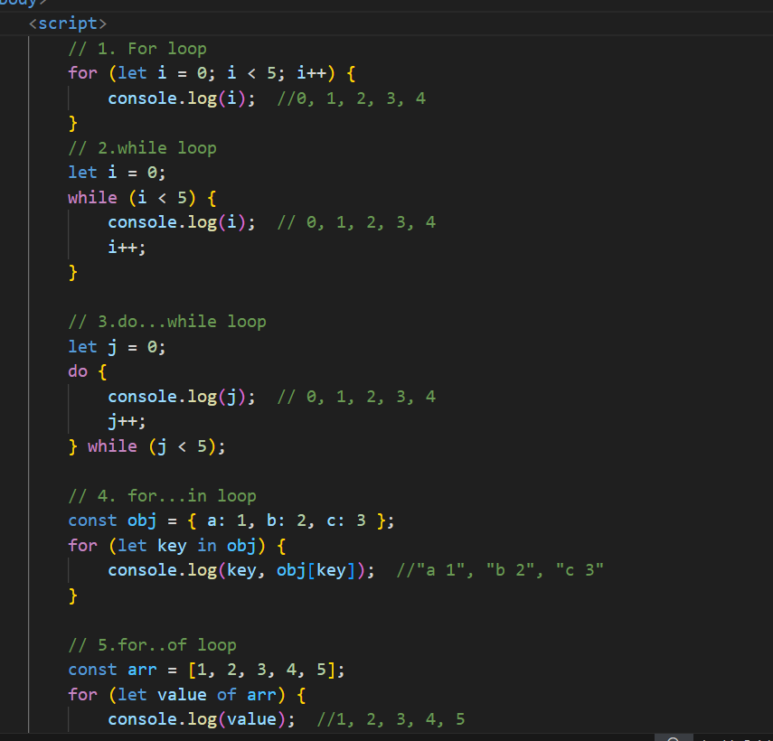

**Que 19.** **What is the use of is Nan function?**

**Ans 19. NaN function** is used when you give two value and one of them is string value

**Example:**

Let n1 = “hello”;

Let n2 = 22;

Document. write(n1+n2);

Result: Nan. Not a number, as we have passed one string value and trying to add with number so, not possible.

**Que 20.** **What is the difference between && and || in JavaScript?**

**Ans 20.**

In JavaScript, && (logical AND) and || (logical OR) are logical operators used to combine multiple conditions and control the flow of the program based on the evaluation of these conditions.

**Logical AND (&&)**

* **Syntax:** condition1 && condition2
* **Function:** The && operator returns true if both condition1 and condition2 are true. If either condition is false, it returns false.
* **Short-circuit Evaluation:** The && operator uses short-circuit evaluation. This means that if the first condition is false, it doesn't evaluate the second condition because the overall expression cannot be true.

**Logical OR (||):**

* **Syntax**: condition1 || condition2
* **Function**: The || operator returns true if at least one of condition1 or condition2 is true. If both conditions are false, it returns false.
* **Short-circuit Evaluation**: The || operator uses short-circuit evaluation. This means that if the first condition is true, it doesn't evaluate the second condition because the overall expression is already true.

**Q.21 What is the use of Void (0)?**

**Ans 21:** In JavaScript, void (0) is an expression that evaluates to undefined. It is often used in situations where you need to generate an expression that has no side effects and returns undefined. One of the common uses of void (0) is to create "do-nothing" hyperlinks that don't navigate to another page or cause any other action.

USE CASE:

**Prevent Default Behaviour in Links**: One common use of void(0) is to prevent a hyperlink from navigating to a new page. For example, if you want a link to execute JavaScript code without refreshing or navigating the page, you can use void(0) in the href attribute.

**Event Handlers:** void (0) can be used in event handlers to explicitly indicate that no value should be returned, ensuring that no default actions are triggered.

**(Conditional looping program)**

**Note: Placed in code file from 30 to 39 conditional all programming file**

**(Array and object Question)**

**[Folder of array solved program]**